Network Threats And Mitigation & Physical Security and Risk
Tasks
1.
Create a table listing 5 common network threats (such as phishing, DDoS, man-in-the-middle, malware, and password attacks), and for each, write one real-world example from an app or service you use (like WhatsApp, Instagram, or Paytm).
ANS :
Network Threat | Description | Real-World Example
Phishing | Fake messages or websites used to steal user credentials. | A fake Instagram login page sent through a DM asking users to verify their account.
DDoS (Distributed Denial of Service) | Attackers flood a server with traffic to make it unavailable. | A DDoS attack targeting Paytm's servers could prevent users from making payments.
Man-in-the-Middle (MITM) | An attacker intercepts communication between two parties. | Using WhatsApp on an unsecured public Wi-Fi network where an attacker attempts to intercept traffic.
Malware | Malicious software that damages systems or steals data. | Downloading a fake WhatsApp APK containing spyware.
Password Attack | Attempts to guess or steal passwords through brute force or credential stuffing. | Attackers trying leaked passwords to gain access to Instagram accounts.

2.
Simulate a brute-force attack scenario by writing a simple Python script that tries to guess a 4-digit PIN code by checking all possible combinations against a preset value.<br><br><em><strong>Constraint:</strong> The script should print the number of attempts it took to guess the correct PIN.</em>
ANS :
# Preset 4-digit PIN
correct_pin = "1234"

attempts = 0

for i in range(10000):
guess = str(i).zfill(4)
attempts += 1

if guess == correct_pin:
print("PIN found:", guess)
print("Number of attempts:", attempts)
break
Sample Output:
PIN found: 1234
Number of attempts: 1235
3.
List 4 physical security risks that could affect a server room hosting a popular app like Zomato or BookMyShow, and suggest one mitigation step for each risk.
ANS :
Physical Security Risk | Mitigation Step
Unauthorized access to server room | Install biometric access control systems.
Fire or electrical short circuit | Install fire detection and suppression systems.
Theft of servers or networking equipment | Use CCTV surveillance and lockable server racks.
Power failure | Use UPS and backup generators.

4.
Draw a simple floor plan (hand-drawn or digital) of a small office and mark at least 3 physical security measures you would implement to protect network equipment (such as CCTV, biometric access, or cable locks).
ANS :
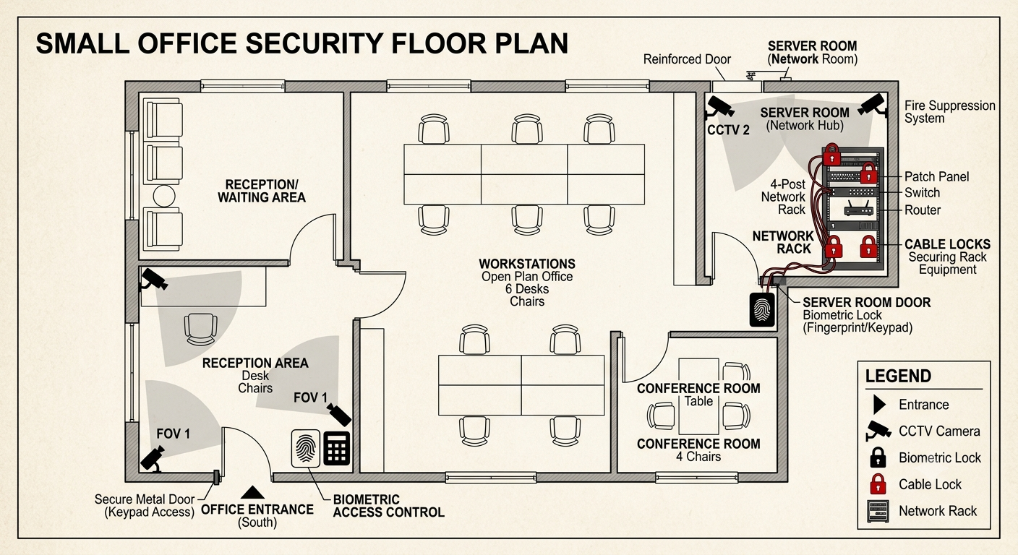
- Biometric Access: A fingerprint scanner is installed at the main entrance, ensuring only authorized personnel can enter the office suite.
- CCTV Surveillance: A high-definition security camera is strategically placed to monitor the reception area and, crucially, the main entrance of the Server Room.
- Cable Locks: Inside the secured Server Room, all valuable rack equipment and network switches are physically secured with heavy-duty cable locks to prevent theft or tampering.

5.
Use ChatGPT or a similar AI tool to generate a checklist of 7 actions a network admin should take to mitigate risks from both network threats and physical security breaches, then review and edit the checklist to make it specific for a college computer lab environment.
ANS :
Security Checklist
- Install and regularly update antivirus software on all lab computers.
- Enable firewalls on all computers and network devices.
- Enforce strong password policies for students and staff.
- Restrict access to networking equipment using locked cabinets or rooms.
- Install CCTV cameras to monitor the computer lab and server area.
- Regularly back up important academic and administrative data.
- Keep operating systems and software updated with the latest security patches.
Edited for College Computer Lab Environment
- Ensure students cannot install unauthorized software.
- Disable unused USB ports where appropriate.
- Monitor internet usage and block malicious websites.
- Secure Wi-Fi using WPA3 encryption and strong passwords.
- Limit administrative privileges to IT staff only.
- Conduct regular security awareness training for students.
- Maintain attendance and access logs for the server room.

